**Lesson 4 Demo 1**

**Create new User in Jenkins**

Steps to be followed:

1. Log in to Jenkins CI tool
2. Access User management section to manage Users

**Step 1: Log in to Jenkins CI Tool**

1. Login to Jenkins CI tool with admin user so that you can access User management section:  
   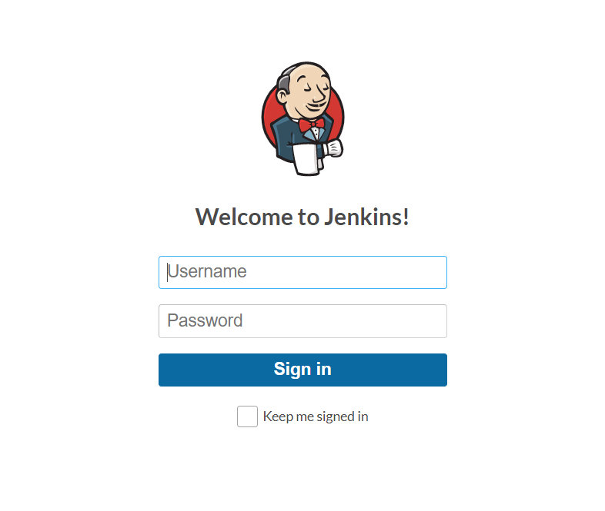

**Step 2: Access User management to manage users:**

1. Access User management section by navigating to Manage Jenkins 🡪 Manage Users:

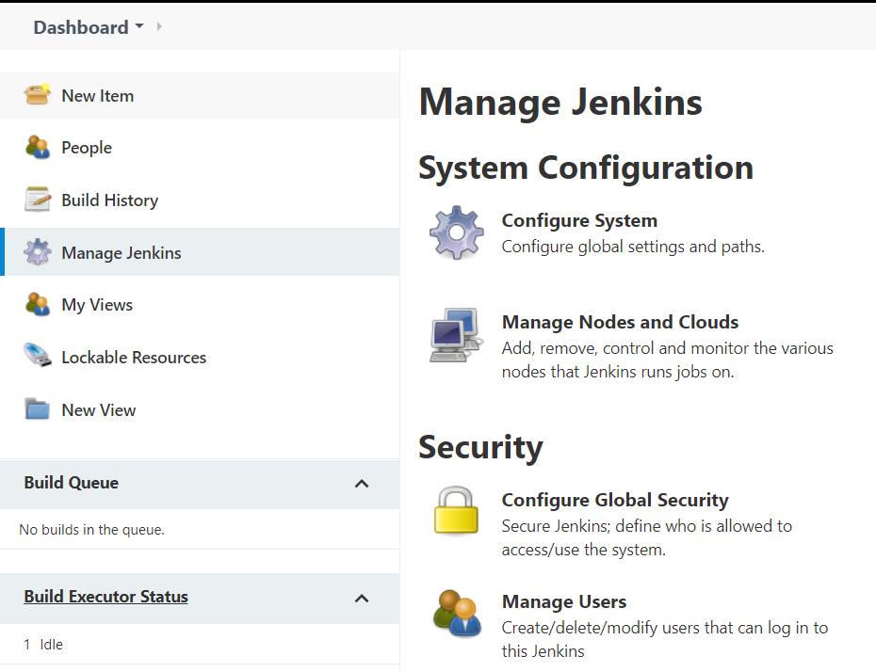

1. Once Manage Users is selected you would see a list of users available in Jenkins. You can either create new users or you can manage existing users.

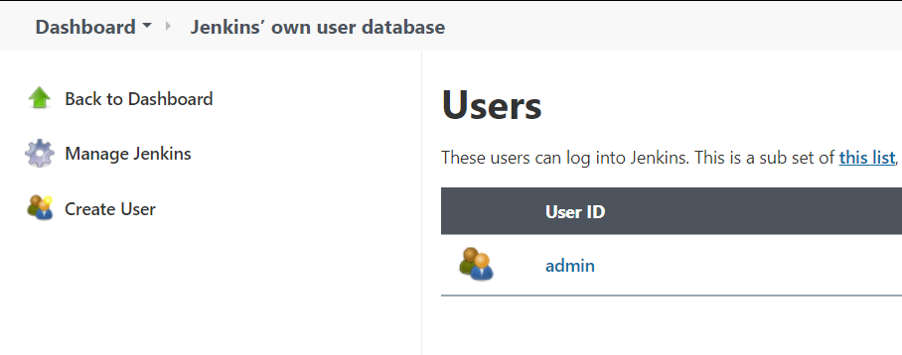

1. Click on Create user and a new screen will be loaded which will take basic user details including Name, password and Email id.

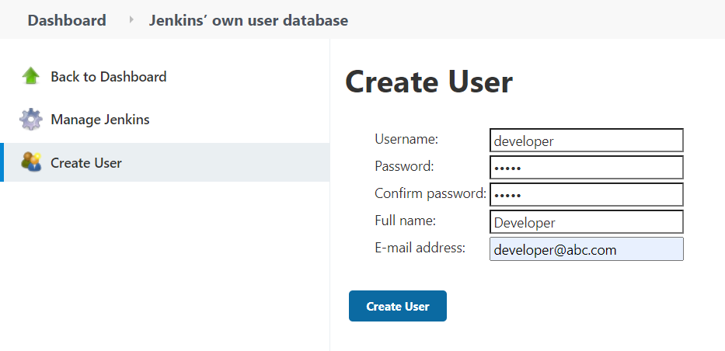

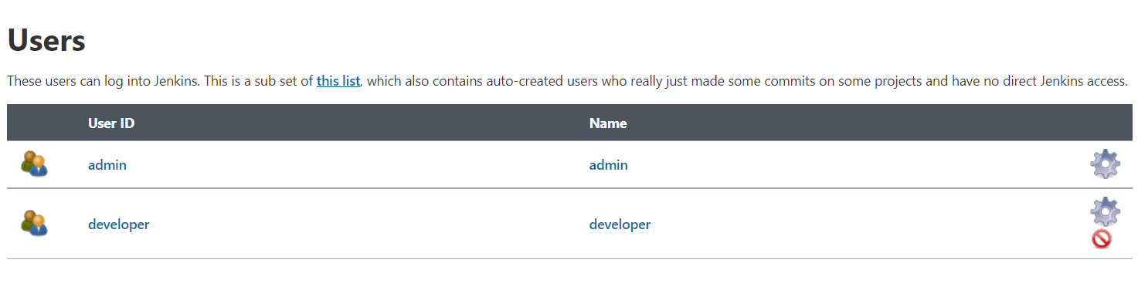

1. Once user is created you can use these credentials to access Jenkins application.